### Experiment – No-4

|  |  |  |
| --- | --- | --- |
| Objective: Program to print the sum of power of 1 , 2, 3, ……,n. | | |
| Scheduled Date | Compiled Date | Submission Date |
| 10-Jan-2021 | 09-Jan-2021 | 10-Jan-2021 |

### Program : Program to print the sum of power of 1 , 2, 3, ……,n.

### Algorithm

Step 1: Start

Step 2: [ Take Input ] Variable : I, n, sum.

Step 3: Read the variable n

Step 4: Given:

Sum=(n*(n+1)*(2*n+1))/6

Step 5: Print sum.

Step 6: Exit.

**Program**

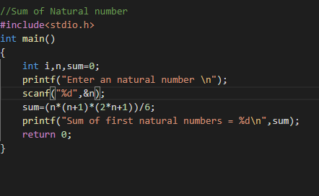

### Output Screen

### C:\Users\WIN10\Pictures\ss11.png